**Test Project**

**Overview**

As a candidate for the Product Operations Associate role, you are tasked with a project focusing on a Point of Sale (POS) system. This test project will allow you to demonstrate your analytical skills, understanding of POS operations, and ability to provide actionable insights for process improvement.

**Project Brief**

Scenario: Assume you are working for a Software company that have a POS system. The system has been operational for the last six months. Your task is to analyze the POS system’s operational processes, identify areas for improvement, and propose a plan to enhance efficiency and effectiveness.

**Analysis:**

**Sprint Duration:** Sprints ranged from 2 to 3 weeks, within a good range for agile teams.

**Features Released:**

* Sprint 1 released the most features (5) in the shortest time (2 weeks), indicating high productivity.
* Sprint 4 released the fewest features (1) with the longest duration (3 weeks), suggesting potential bottlenecks.

**Bugs Reported:**

Sprints 1 and 3 had the most bugs reported (5), while sprints 2 and 5 had fewer (3). This could be due to feature complexity or testing effort.

**Bugs Resolved:**

Sprints 1 and 3 resolved all reported bugs (5).

Sprints 2 and 5 had unresolved bugs (2), indicating time constraints or limitations in testing efforts.

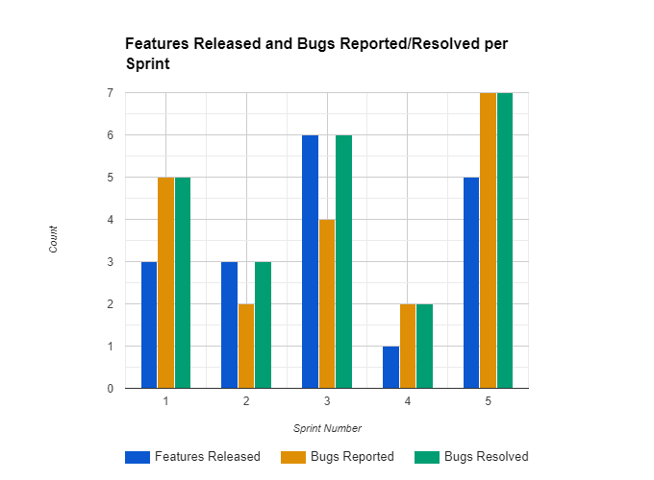

**Performance Analysis:**

**Sprint Duration** **vs. Features Released**: A weak negative correlation suggests longer sprints do not always lead to more features.

**Reported Bugs vs. Resolved:** Positive correlation suggests sprints with more reported bugs also tend to have more resolved bugs.

**Sprint Duration vs. Reported Bugs:** Weak positive correlation suggests longer sprints might lead to slightly more reported bugs.

**Solutions:**

* Standardize feature complexity for better workload management.
* Identify and address bottlenecks in sprint 4.
* Prioritize bug fixing with sufficient time and resources.
* Implement CI/CD for improved software quality and frequent releases.
* Regularly review and improve processes via retrospectives.

**Additional Recommendations:**

Track code coverage, code quality, and user feedback for a comprehensive understanding.

Consider dedicated project management tools for tasks, resources, and communication.

Encourage continuous learning and knowledge sharing within the team.

By implementing these suggestions and continuously analyzing performance data, the team can optimize their workflow and improve the quality and speed of POS system development.

**Quantitative Data (POS System Performance):**

Average Transaction Value: The average transaction value remained relatively stable at around $25.

**Sales:**

March and May saw the highest sales ($38,000 and $40,000 respectively).

February and June saw the lowest ($28,000 and $35,000 respectively).

A seasonal trend may be present, with potential peaks in spring and early summer.

**Transactions:**

April and May saw the highest number of transactions (1300 and 1600 respectively).

February saw the lowest (1100).

The number of transactions may correlate with sales.

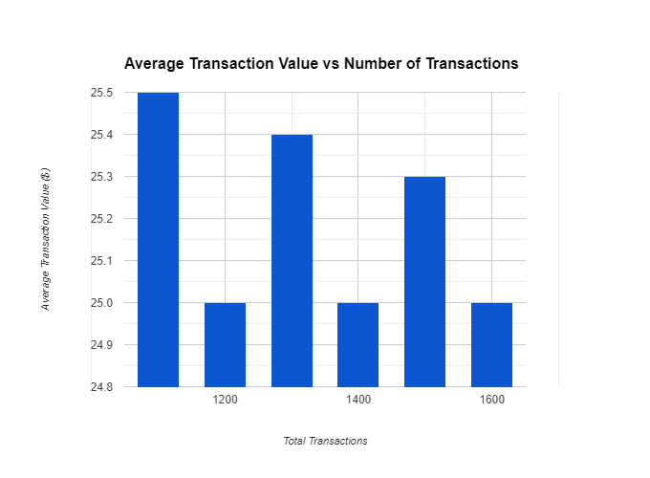

**Peak Hour Sales:**

Weekday evenings (17:00 - 20:00) consistently saw peak hour sales.

Weekend peak hours may differ and require further analysis.

**Refunds:**

The number of refunds varied between 18 and 30 per month.

High refund rates in May and June might warrant further investigation.

**Qualitative Data (Customer Feedback):**

Overall Positive Sentiment: Most customers reported positive experiences with the POS system.

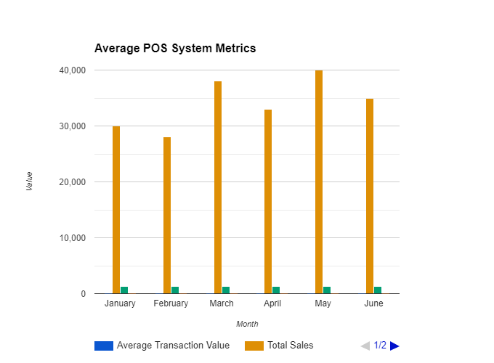

**Specific Feedback:**

**Feedback ID 102:** Delay in payment processing requires investigation and potential system improvement.

**Feedback ID 103**: Desire for more payment options suggests adding features to enhance customer satisfaction.

**Feedback ID 104:** Positive experience with staff intervention despite refund issue highlights importance of responsive and helpful staff.

**Feedback ID 105:** Appreciation for new contactless payment feature highlights successful implementation of new functionalities.

**Combined Analysis:**

**Correlations:**

High sales months tend to correlate with high transaction numbers, supporting the hypothesis that sales volume is directly related to customer traffic.

Peak-hour sales may influence staffing schedules and resource allocation.

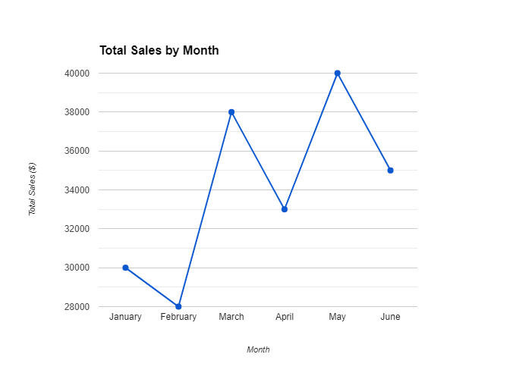

**Areas for Improvement:**

* Investigating payment processing delays and implementing solutions to ensure smooth transactions.
* Exploring adding more payment options based on customer feedback.
* Evaluating refund processes to minimize occurrences and improve customer experience.

**Additional Recommendations:**

**Customer Segmentation**: Analyzing customer demographics and preferences to tailor marketing campaigns and improve customer service.

**Regular System Updates:** Implementing updates and bug fixes based on user feedback and identified issues.

**Employee Training:** Providing training to staff on system functionalities and handling customer inquiries and issues efficiently.

By analyzing both quantitative and qualitative data, the organization can gain valuable insights into the performance and user experience of their POS system. This information can be used to identify areas for improvement, implement effective solutions, and ultimately enhance customer satisfaction and business performance.